CDK:

Easiness for development with lesser and easy infrastructure (yml) and coding

What is Subnet:

A subnet, or subnetwork, is a segmented piece of a larger network. More specifically, subnets are a logical partition of an IP network into multiple, smaller network segments.

Organizations will use a subnet to subdivide large networks into smaller, [more efficient subnetworks](https://searchnetworking.techtarget.com/feature/Subnetting-to-increase-performance). One goal of a subnet is to split a large network into a grouping of smaller, interconnected networks to help minimize traffic. This way, traffic doesn't have to flow through unnecessary routs, increasing network speeds.

Each subnet allows its connected devices to communicate with each other, while routers are used to communicate between subnets. The size of a subnet depends on the connectivity requirements and the network technology employed. A point-to-point subnet allows two devices to connect, while a [data center](https://searchdatacenter.techtarget.com/definition/data-center) subnet might be designed to connect many more devices.

FARGATE:

Fargate makes it easy for you to focus on building your applications. Fargate removes the need to provision and manage servers, lets you specify and pay for resources per application, and improves security through application isolation by design.

Amazon Elastic Container Service(ECS):

Highly secure, reliable, and scalable way to run containers

Customers such as Duolingo, Samsung, GE, and Cookpad use ECS to run their most sensitive and mission critical applications because of its security, reliability, and scalability.

Benefit of running your ECS clusters using [AWS Fargate](https://aws.amazon.com/fargate/), which is serverless compute for containers. Fargate removes the need to provision and manage servers, lets you specify and pay for resources per application, and improves security through application isolation by design.

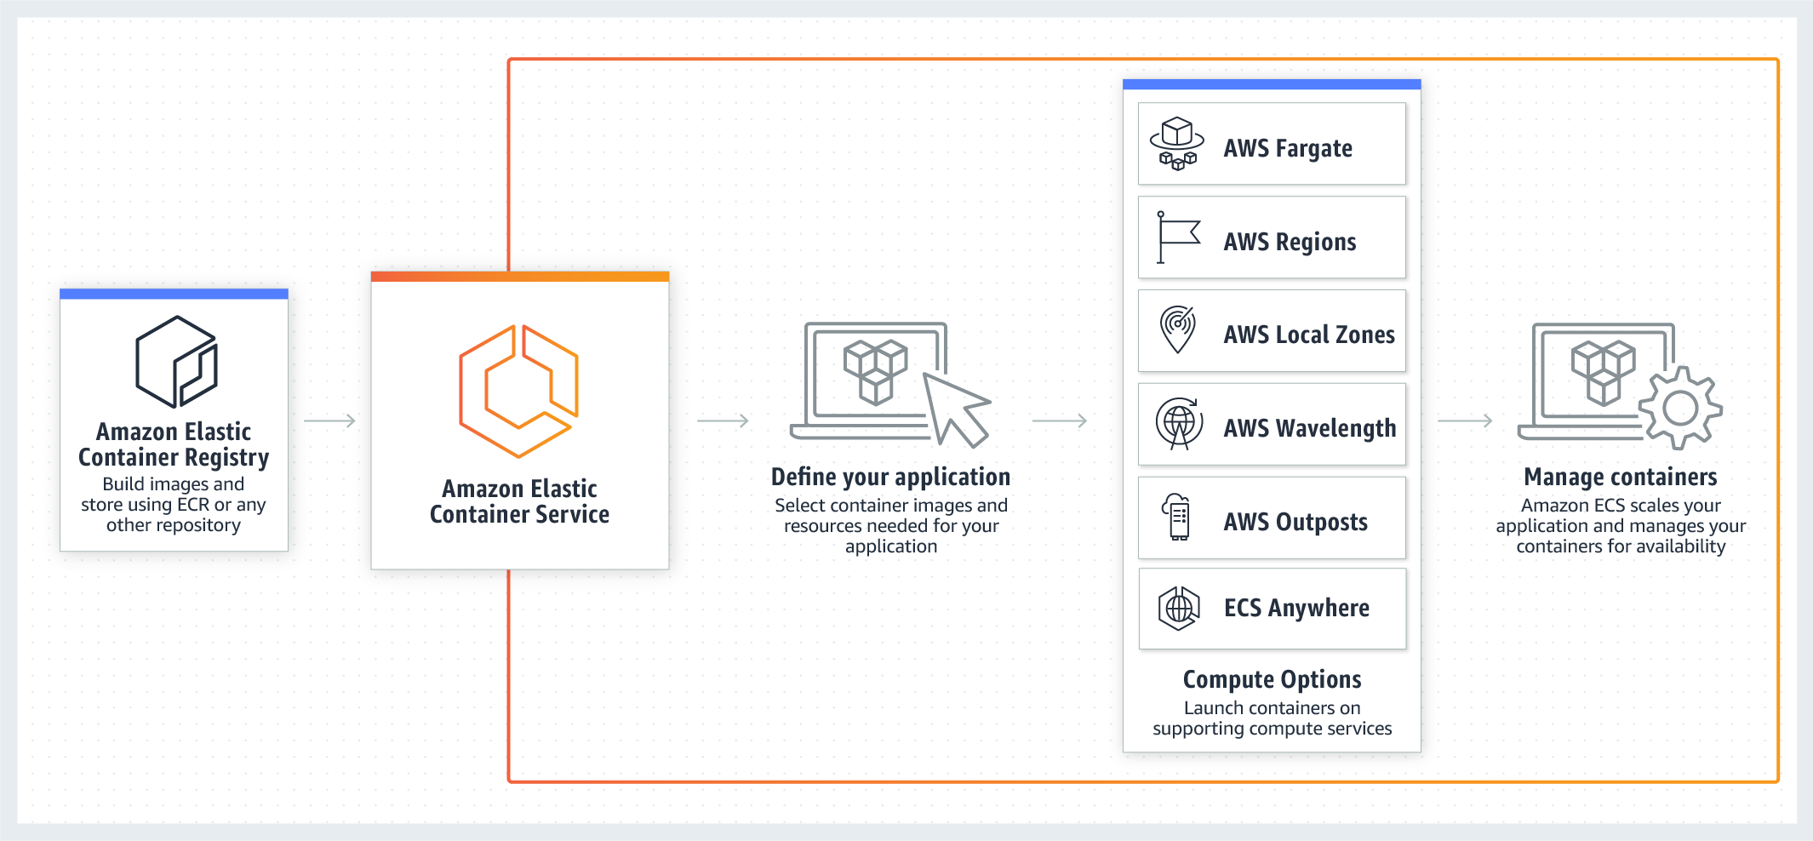

ECS vs EC2:

**EC2** allows you to launch individual instances which you can use for pretty much whatever you like. **ECS** is a container service, which means it will launch instances that will be ready to launch container applications.

Does ECS use EC2?

No. **AWS ECS** is just a logical grouping (cluster) of **EC2** instances, and all the **EC2** instances part of an **ECS** act as Docker host i.e. **ECS** can send command to launch a container on them ( **EC2** ). If you already have an **EC2**, and then launch **ECS**, you'll still have a single instance

WHY VPC?

VPC used for networking. Virtual Private Cloud to provide security by means of network partitioning

DEFINITIONS:

* **App** - A collection of related stacks.
* **Stack** - The set of AWS resources that are created and managed as a single unit when AWS CloudFormation instantiates a template
* **Construct** - Everything defined in the CDK is a Construct. It can be thought of as a re-usable “Cloud Component” representing anything from a single AWS resource to architectures of arbitrary complexity.

CIDR:

Classless Inter-Domain Routing is a method for allocating IP addresses and for IP routing

For Deployment:

First define s3 bucket L1

Then distribution using cloundfront and pass above created bucket

Then for url, distribution will be passed in cdk.CfnOutput

Then for complete deployment, we use s3 bucket deployment and first pass source folder like build in react or Gatsby, second s3 bucket, exclude web/static, and in the end distribution

GRAPH DATABASE:

Graph database is a latest database technology which consist of nodes (and properties) which works similar to dots in graph.

It consists of direct or indirect relationships between nodes which can be easily access when required. It uses schema for data handling. Gremlin is a programming language which used in it.

SECURITY GROUP:

[Accessing Amazon Neptune from AWS Lambda Functions | aws-dbs-refarch-graph (aws-ysamples.github.io)](https://aws-samples.github.io/aws-dbs-refarch-graph/src/accessing-from-aws-lambda/#:~:text=Amazon%20Neptune%20runs%20inside%20your,or%20a%20Network%20Load%20Balancer)

Security group rules enable you to filter traffic based on protocols and port numbers.

Default security group always their when VPC created

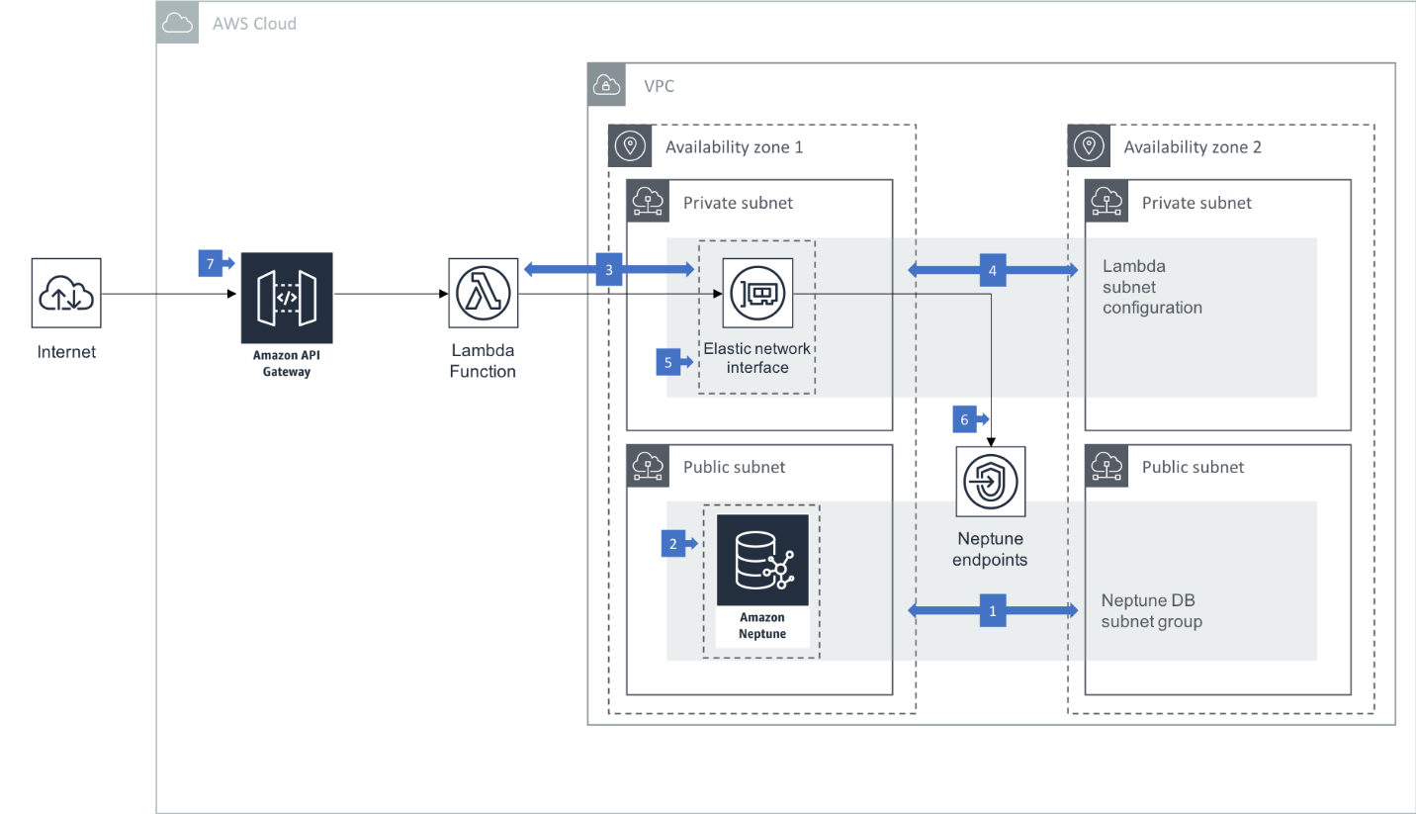

GraphQL API:

Appsync -> implements graphql in aws with any service. Also security and authorization

Datasources -> lambda, http endpoint, dynamodb

Api gateway, for traffic use security group, then VPC, then subnet and then it reaches to lambda

So final security->security group, VPC, subnet

For deployment

Amplify init

Amplify codegen –api id sfsafafas

Amplify server

Subscription

Real time mutation update with the help of subscribe.

COGNITO:

Sign in/ signup or user authentication

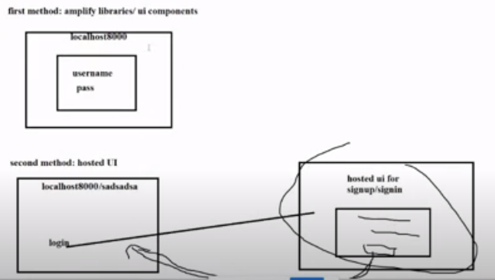

Difference b/w role and user:

We can attach different policies with the IAM role. Role can access services by assigning permissions to services. We create a role to give access of particular service. And that particular service can access different services based on policies. Role cannot be assigned to the user. We can assign policy or group to user

AWS secret manager:

Keep your secrets save and update them on rotational bases as we want.

As lambda function access secret manager so we need to give lambda function access of secret manager

AWS CICD PIPELINE:

We just push code to repository. Rest of the build and deployment will be automatic.

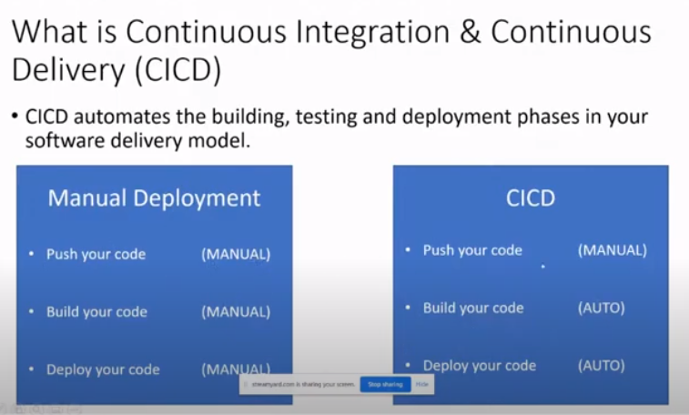  
In aws;

Backend deployment->cloudformation

Frontend deployment->S3 bucket

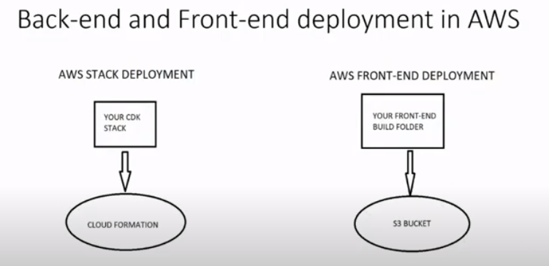

BACKEND CICD:

Code Pipeline

Different folder for backend stack and different folder for the code pipeline stack

First push backend folder to git repo, then call it in code pipeline folder

We first need to call backend stack name in code pipeline stack in starting of codepipeline under const stackname

First stage is to fetch the code

Second is to build the code

And the Third is to deploy the code

CODE PIPELINE WORKFLOW:

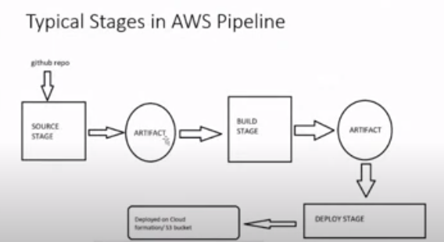

Artifact is the temporary storage used to transfer data in multiple stages

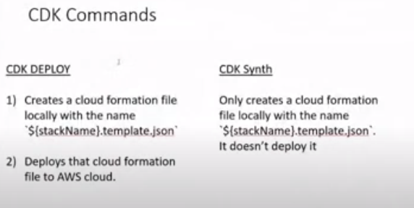

After completing code pipeline. In the same folder we need to run these command to automate the process

Npm run build

Cdk deploy

This is for backend CICD

FOR FRONTEND CICD:

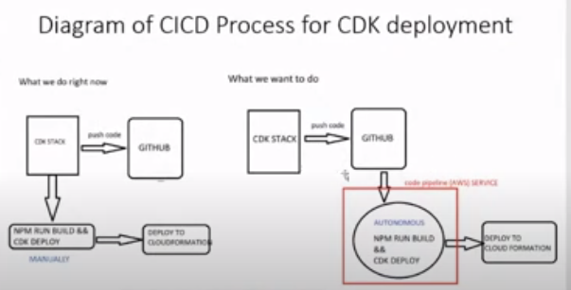

In this we create our frontend and push it to some new repo. Now create code pipeline for frontend which uses S3 bucket as our frontend deploy on s3 and backend on cloudformation. In code pipeline folder, we again pass our repo name and token, and first we write

Gatsby build

in our app to generate public folder.

Now go to frontend pipeline folder. And in that after completing,

Npm run build

Cdk deploy

We need to deploy first time. Afterwards, we just need to push our code to git repo and pipeline will run automatically

EVENT BRIDGE:

It is used for event driven architecture. All applications are loosely coupled. It works on events, where all applications are not dependent on each other. It is a-synchronous. Non even driven architecture are synchronous systems. Like if one service fails, other services also tends to fail or we need to update the services related to that services.

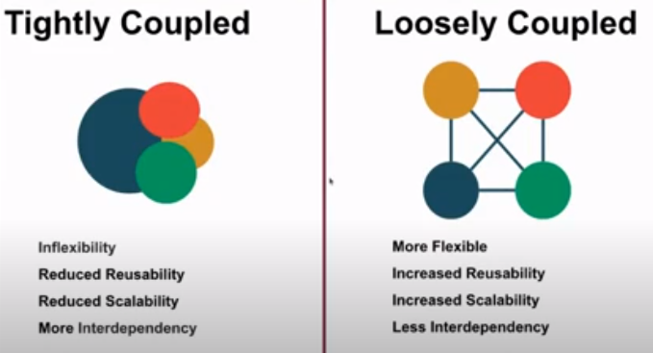

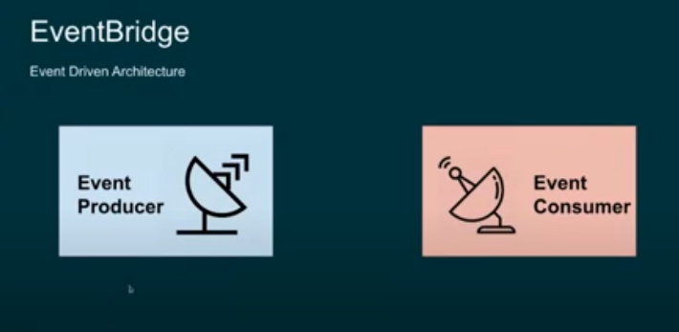

Event bus responsible that which event forwarded to which service. It is like a filter

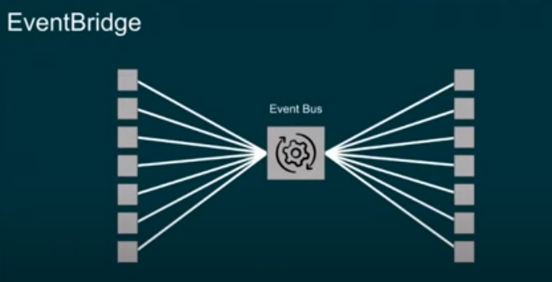

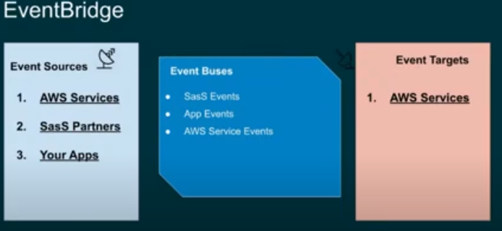

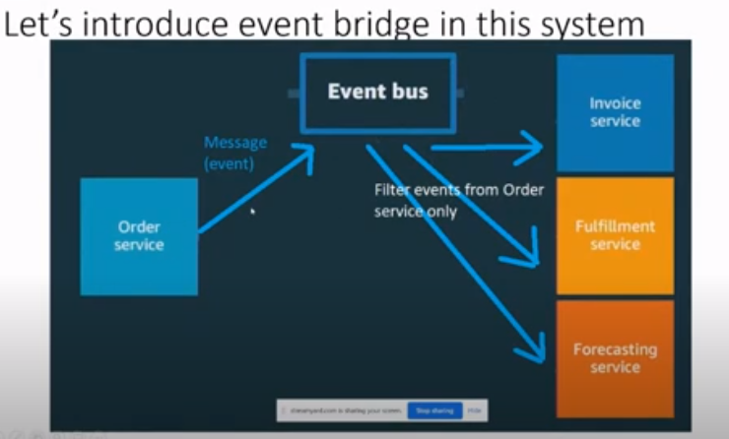

BENEFITS OF EVENT DRIVEN:

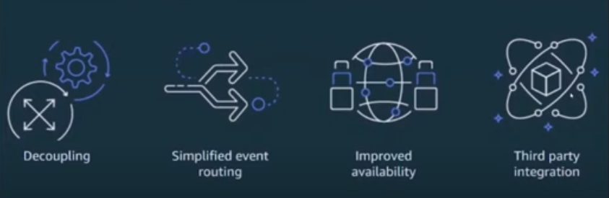

Like if we create a rule for lambda, then any service which has a source lambda, will obey that rule or that rule will be applied to that service. The service which we want to follow that rule should be comes under target.

PRODUCER VS CONSUMER:

Producer produces an event and then give it to event bus and the other related stuff. That event is consumed by consumer and it can be used to update db or logs etc.

SNS:

Messaging service. One to many relationship

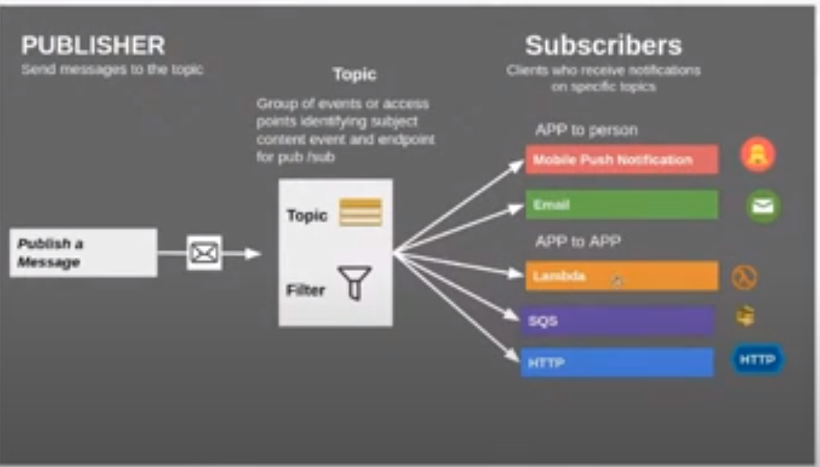

It is pushed based service.

SQS:

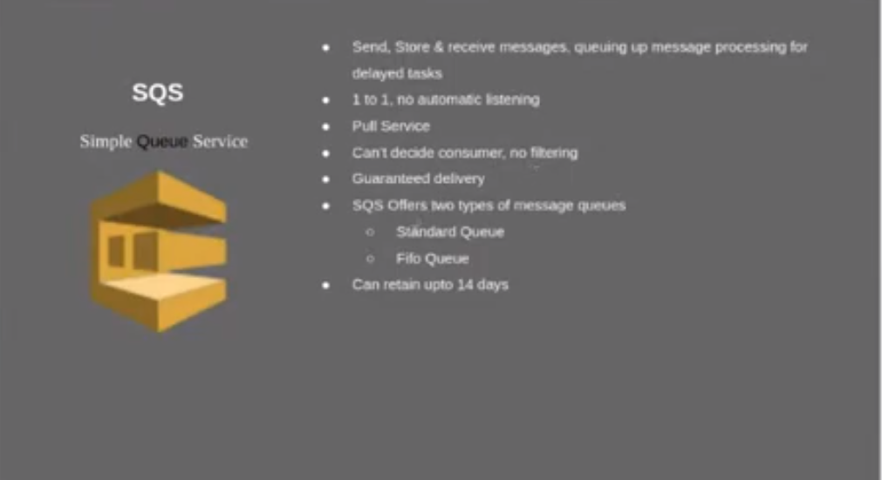

This is also messaging service but used when we want msg in order. So it holds other msgs till previous msg sent. It is pull based service. Consumer need to pull from the queue as per its need.

Standard queue->not ordered

Fifo queue->ordered (first in first out)

SES:

Email service.

When we want to receive email in SES, we need to have verify domain connected in SES

In sending, we need to verify domain in SES, we can do this with gmail etc

1. Invoke lambda function when we receive email in SES domain

This is triggered in receiptents, where we placed our domain. So when we receive email on our domain, rule set will invoke lambda

We can create many Rule set(containingmany rules), but we need to activate one rules set at a time

2. saving received email in s3 bucket

3. Sending an email using SDK

SNS:

Dead letter queue saved fail msgs, temporary storage using SQS.

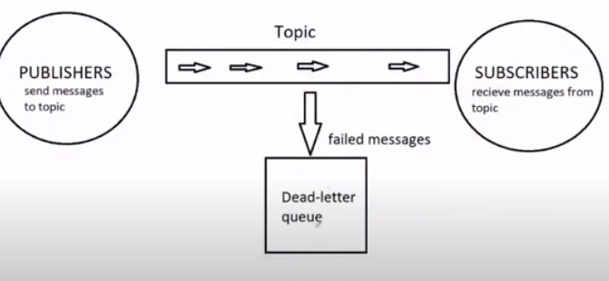

SNS sends msgs through topic

SQS sends msgs through queue

PINPOINT:

Used for marketing

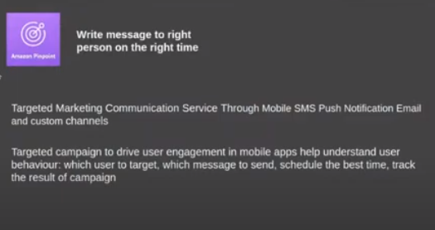

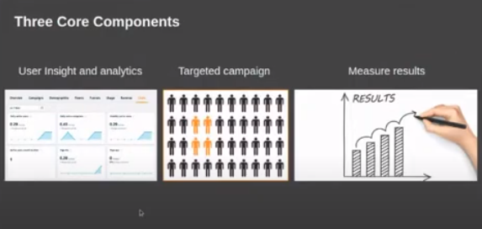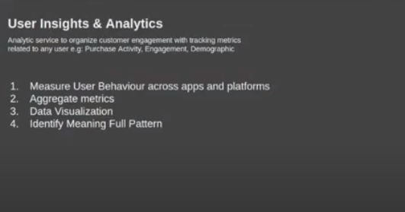

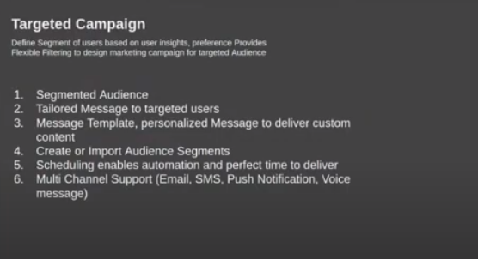

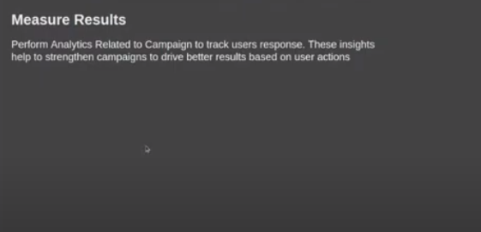

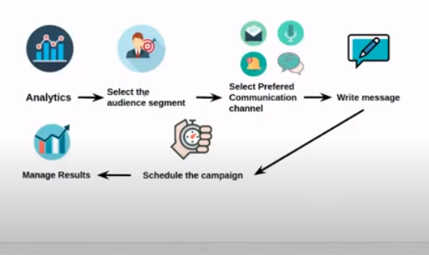

To do marketing based on some analytics, we need to have data first about users of app and their usage. For that, we need to integrate our app with aws and register endpoint(email etc) with aws

STEP FUNCTION:

Step function is helpful in doing state management. It manages how different aws services like many lambda services communicate together or with different services or in performing parallel operation side by side or in error handling. Step functions executes sequentially in steps. Output of the previous step becomes the input of the next step

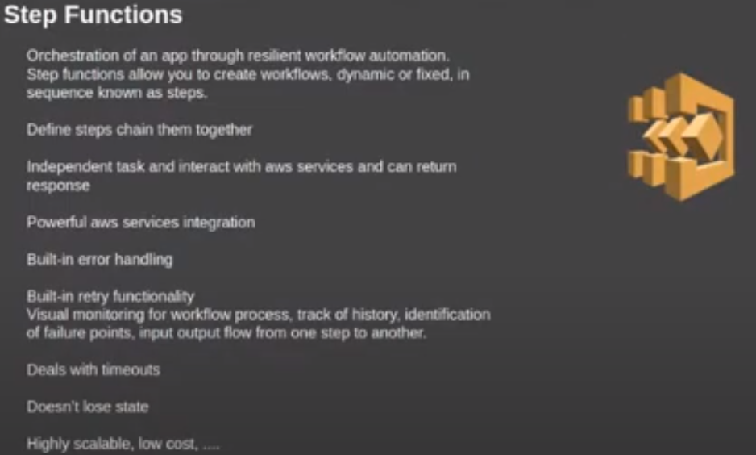

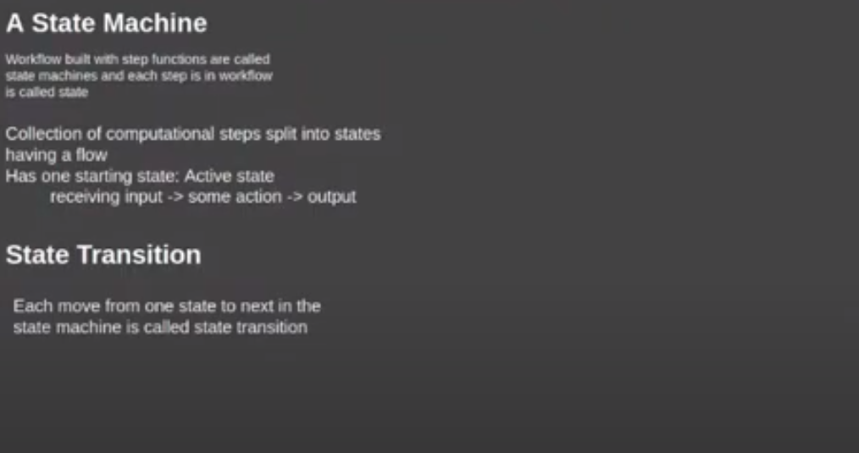

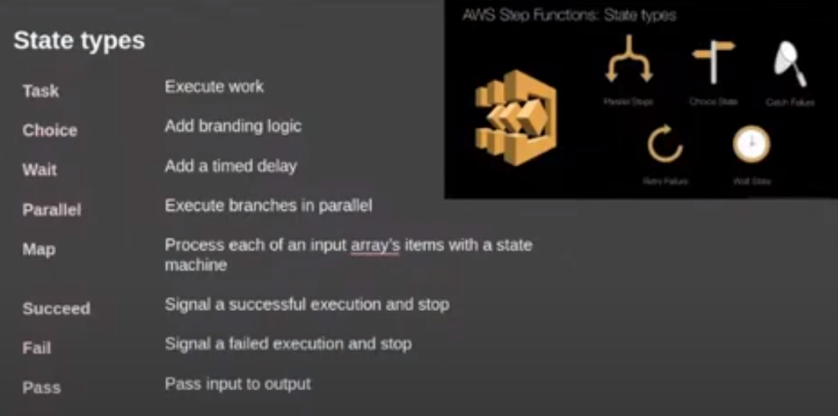

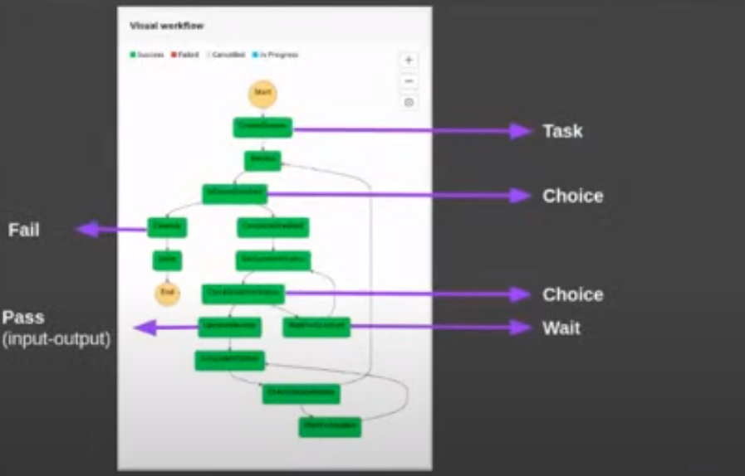

Basic example

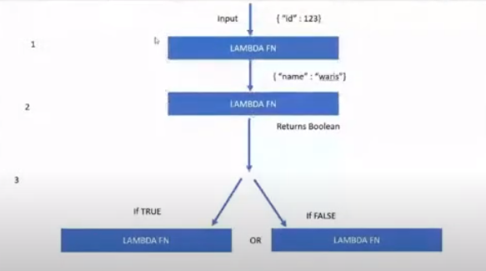

WorkFlow:

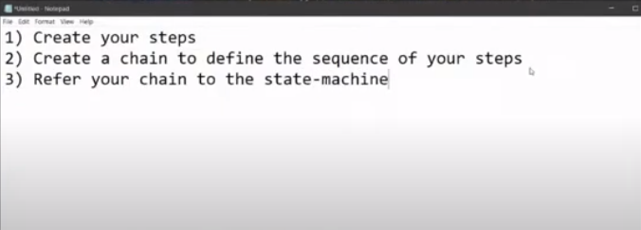

Incase of lambda function, we first need to define or initialize lambda function, and then give it to step

Other thing is pass step. It becomes step at the time of initializing it. We don’t need to create step function separately for it

By default, pass function takes your inp and pass it to the output. But there is not use of it. We can make use of it by passing some additional static data

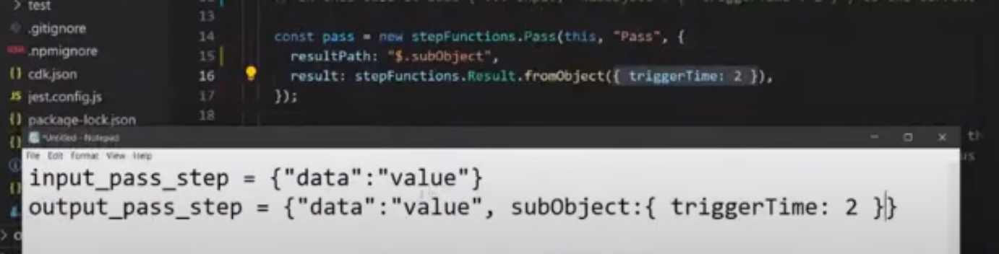

Wait step do some wait by passing input to output. Input and output is same.

Map step is like a loop. But is requires array so that it can map over it and for every value of array, it can run some action or lambda function

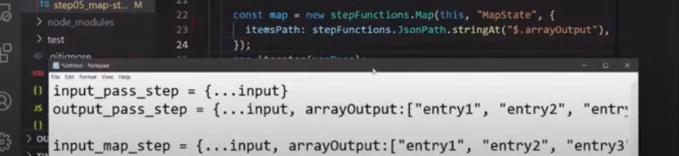

Map.iterator(MapPass)

The above command means iterate over the array and for each element, run map pass to it

Output of each iteration will be combined to an array also.

AWS Timestream DB:

Used for data with timestamps. Like data of iot. For data visualization, we use graffana. First we need data, then we need to store the data with timestamp. We need to analyze and query the data and then do work on it

Latest data store in memory and older data store in magnetic storage, but procedure of quering is same and it is faster

It is real time sql query db. We can only add data. We cannot delete or update data

Dimension describes meta data of time series. It is like latitude and longitude of different trucks at different time. We have two column name. Measure name and measure value. Hostname, az, region, measure name etc are the dimension. So their can be 128 dimensions and 1024 records in one table

CLOUDWATCH VS XRAY:

Xray is also like a debugging tool like cloudwatch but more deeper and provide more comprehensive features to detect logs. It allow to view data in graphs. It track and trace request between different services. In cloudwatch, the monitored info is logs where as in xray, we call them traces.

Annotations are used to filter out the traces(logs).

Like we can search some segment using search bar by using the following segment as per the code.

Annotations.userCompany = “panacloud”

REMOVE AMPLIFY:

To remove amplify, delete .graphqlconfig.yml file from src in frontend. If not work, then delete all amplify related files. Or also run

amplify codegen remove

Lambda Layers:

Runs in the same time

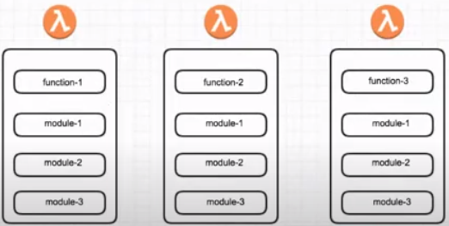

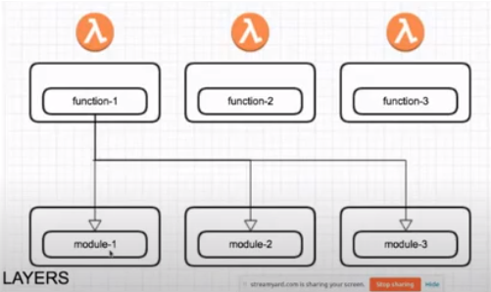

In this, we don’t deploy lambda folder directly. We deploy zip folder by zipping lambda function. We have to create folder node js in lambda function folder and in that, we install dependencies using npm init. After that, we create lambda layer const in stack, in that we pass lambda layer function folder and call that in lambda function in stack. We can create upto 5 layers. Now the libraries we need for lambda will not installed in main folder. It would be install in lambda function layer folder or in nodejs folder as we have already npm inits. By this, we don’t need to install libraries every time in lambda folder. We just install require library in lambda layer function under nodejs folder.

If we create our file let say named auth.ts and want to call it in more than one lambda function. Then for that, we first place that file in lambdalayers folder but not in node js folder as it is our file and not any npm dependency. Now we can call this file in lambda folder in any of the lambda function by using below command

Const abc = require(‘opt/auth.ts’)

Because layer by default resides in opt(optional folder)

Whereas the libraries which are part of npm folder first install in lambdalayer folder under nodejs folder as we have done npm init in it. It also goes in opt folder along with lambda function folder, so we can directly call npm dependency in any of our lambda file under lambda folder like

Const axios = require(‘axios’)

But for our own file, we need to create in lambda layer folder (but not in node js folder as it is not npm library), and to call it in any of the lambda function under lambda folder, we can call it using ‘./opt/filename.ts’). Let say if our own created file in lambda layer folder uses some external library from npm, then what we need to do is first place our file in subfolder like (‘./lambdalayer/subfolder) and in that folder place our own created file like auth.ts

(‘./lambdalayer/subfolder/auth.ts’)

Now to use external dependency in auth.ts(our own created file), we follow the same procedure, like we first create nodejs folder in subfolder, and in that, we do npm init, and then install library in that nodejs folder.

As our lambda function folder does not have any libraries installed, which means we does not get any intellisense(axios.). If we want that, what we can do is we can do npm init in our lambda folder, and after that we can install libraries in it using dev, by this our libraries will be in development and not in production means they will remain locally and will not go to aws which save our space in aws

Like

Npm install axios --save-dev

Now as we were importing like

Const axios = require(‘axios’)

Now we can also import it like

Import axios from ‘axios’

AWS NEPTUNE:

SQL data is relation base, and when database increase, SQL database becomes very complex and difficult to handle. SQL create table

Graph db creates graph consist of nodes(vertices) and edges.

It is used in facebook like searching of friends of friends made easy due to graph db although it is very to find friends of friends.

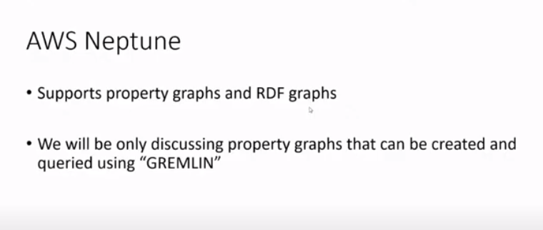

We only see property graphs, using gremlin

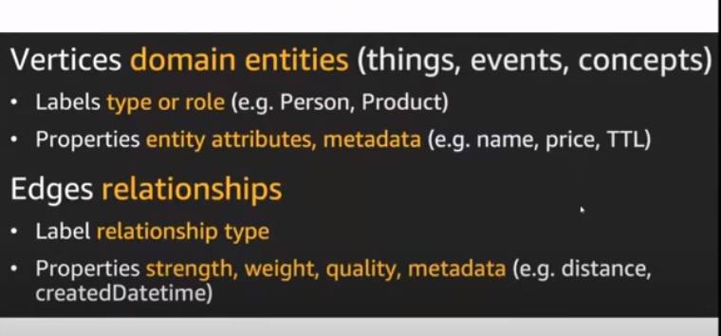

Vertices created for noun. Vertices created have label(kind of vertices) like type of of vertices etc and property is the name etc.

Edges define relationship b/w two vertices or entities. It also has label and properties

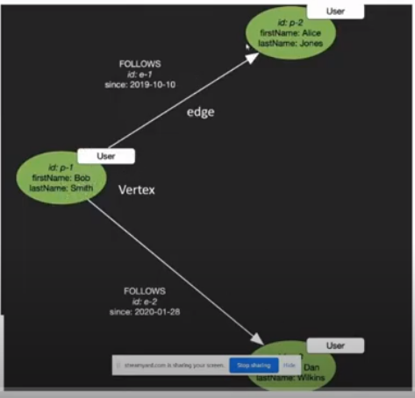

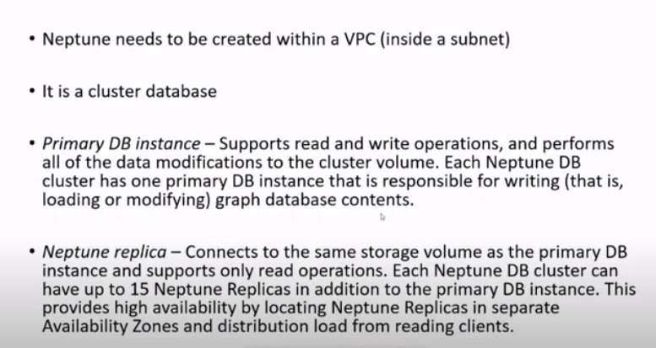Cluster db -> it can have more than one instance

Primary instance -> read and write both

Neptune Replica -> only read

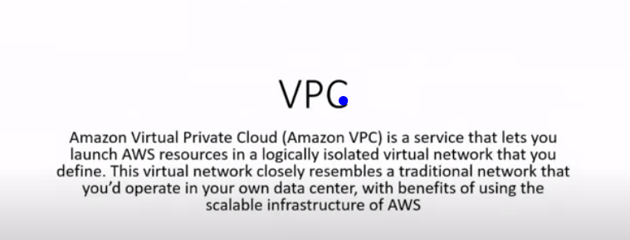

It provides private network with self define rules. Neptune works inside VPC. By creating your vpc, you have your own network

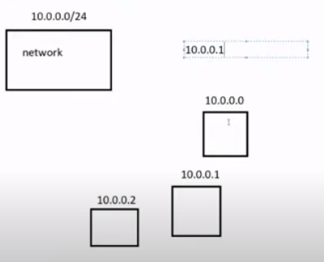

10.0.0 -> these initial segments always remain same defining your network

Last segment 0/24 is the hostname which changes wrt device like 10.0.0.1 etc

0/24 -> subnet mass. How many devices(ip address) connected to your network

Formula :

2^(32 – hostedsubnet mass)

For the above case:

2^(32-34) => 2^(8) = 256

So 256 devices connected to this network

So above will become

10.0.0.0/255

PROCESS TO CREATE VPC:

IPV4 CIDr : 10.0.0.0/24

Default

NOW SUBNET:

Subnet name: public_subnet

IPV4 CIDR: 10.0.0.0/25

We need to create two subnets, out of above 256 devices haif of devices should go to one subnet and haif to the other subnet

So 2^(32-25) => 2^(7) = 128

Create other subnet:

Private_subnet

As from 0 to 128 occupied by first subnet, so here we write

10.0.0.128/25

ROUTE TABLES:

Two route table, one for public and one for private

How traffic is redirecting from the network

Subnet associate, associate public subnet to it. Public means we connect it to normal internet. For this, use internet gateway

INTERNET GATEWAY:

Allows subnet to communicate to internet

Name,

Then actions and attach to vpc

Again go to route, select public, routes, add route and give internet access to it

* + 1. (all internet traffic routes), and in target select internet gw.

Send route through internet using above internet gateway

For private:

We use net gateway. It is one way communication. Subnet send request to internet, internet can respond to that request only, it cannot send anything to your private subnet other than that(or cannot access). We have to create it on our own

Security groups:

Like firewall. Security group sits b/w instance and subnet.

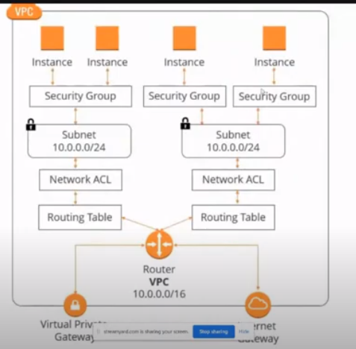

ACL sits b/w routing table and subnet(works on higher level)

Now this is it for VPC.

NEPTUNE:

From gui, first create db

Development and testing

We don’t need to do this from GUI. We do it using CDK from code.

Isolated subnet -> no access to internet at all

In security group, we can define rule for the outbond and inbound traffic

Sg1.addingIngressRule -> means inbound. Add rule to this port. By this we add restriction to inbound traffic that traffic will only be allowed through 8182 port

And no restriction to outbound traffic

After that lambda function is created.

We put our lambda function inside vpc(invocation of your lambda function stays inside vpc, not whole lambda function in vpc)

In the end create apigw that we have attached with our lambda function

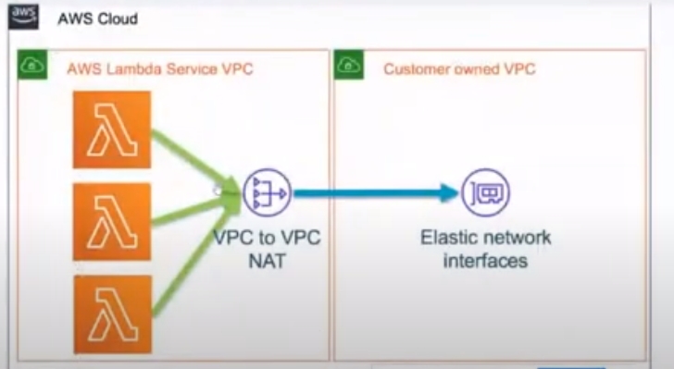

Invokation of lambda can be from anywhere as we know, so whats the deal?

Whats reside inside your lambda handler is bound to the rule of VPC

Handler of lambda function will only be able to access information that inside vpc(and that thing is Neptune), lambda function access Neptune

Conn variable holds connection b/w lambda and Neptune

The above we have done is access neptune using lambda

The other way is:

Access neptune within the ec2 using ec2 instance.(access Neptune using ec2)

CDK DESIGN PATTERNS:

Gang of 4 (for design patterns)

Composite patterns:

Path whole hirearichy

Visitor Pattern:

Stable method of visit in hirearichy. It allows to go to particular node and then loops through all the children or nodes of that particular provided node. (aspects class is used)

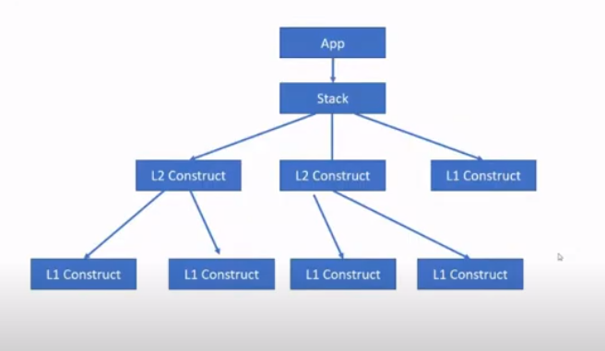

This is the object diagram runs at run time

Last node is leaf node which is mostly L1 construct

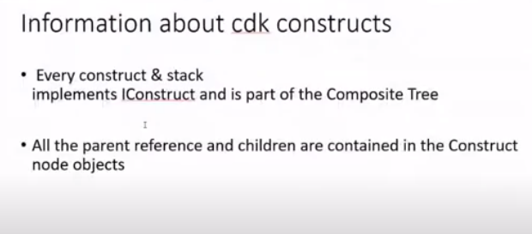

To console, use

Npm run build

Cdk synth

Console.log(Lambdafunction.node.scopes) // all the parents

Console.log(Lambdafunction.node.children) //children

Cloudformation always shows leaf nodes which is L1 constructs

GREMLIN:

Gremlify

Gremlin visualizer

g.V.drop() ->drop initiall queries that comes from tinkerpop

if id given in string than it will use built in ids -> property(“id”, “101”)

if without string, then it will use given ids -> property(id, “101”)

g.V.both() -> bring vertices with inward and outward vertices

g.V.bothE() -> bring vertices with inward and outward vertices

g.V.valueMap() -> properties of all vertices

g.E.valueMap() -> properties of all edges

g.V.elementMap() -> advance of value map, give label id as well

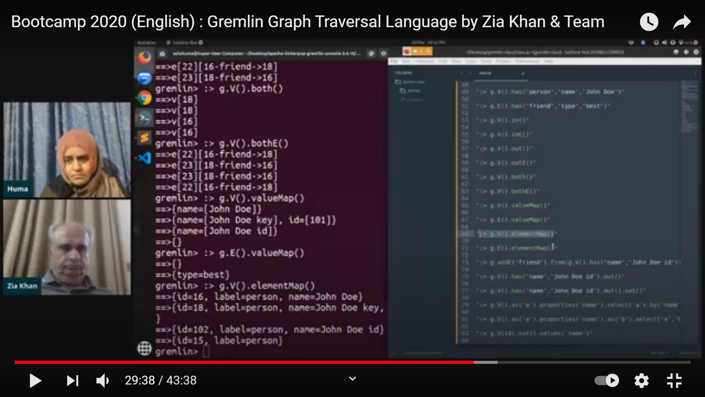

g.V(102).out().hasNext() -> check whether vertex 102 has outward vertex or not

SERVERLESS EVENT DRIVEN ARCHITECTURE:

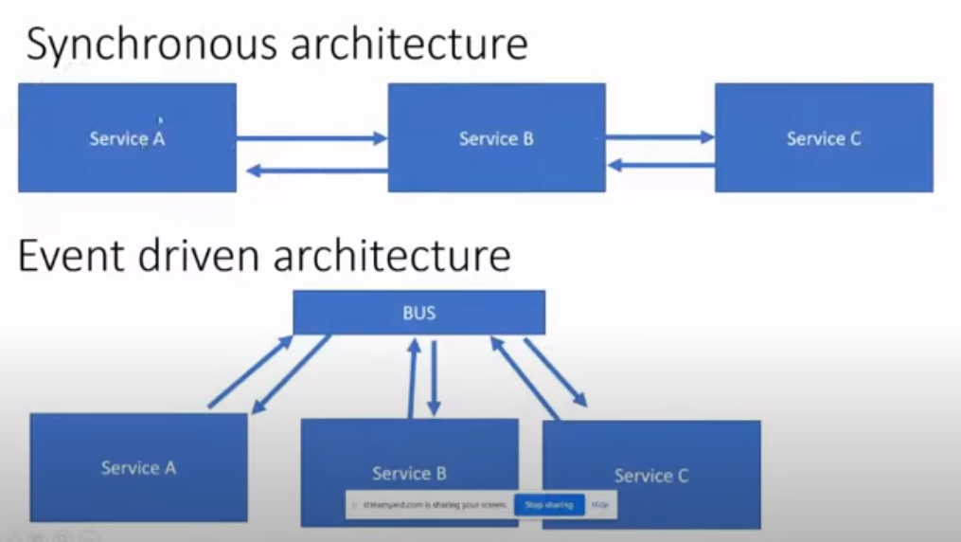

Synchronous or monolithic or request based architecture or tightly coupled

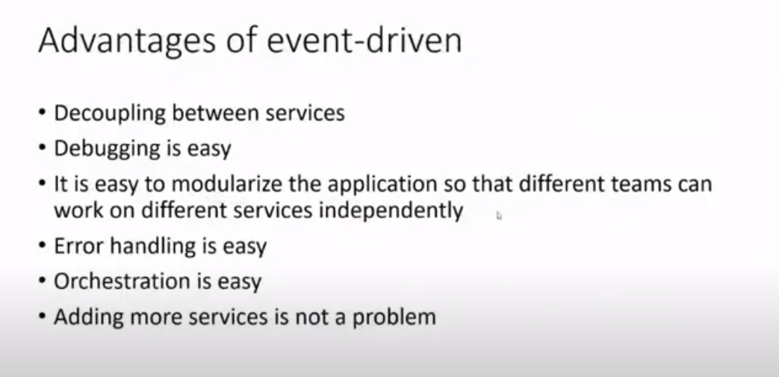

EVENTBRIDGE VS STEP FUNCTIONS:

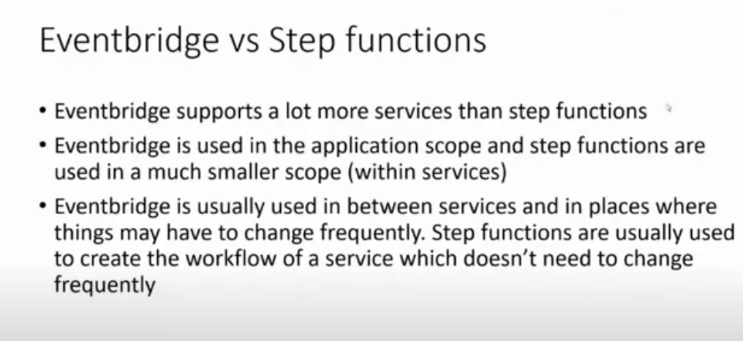

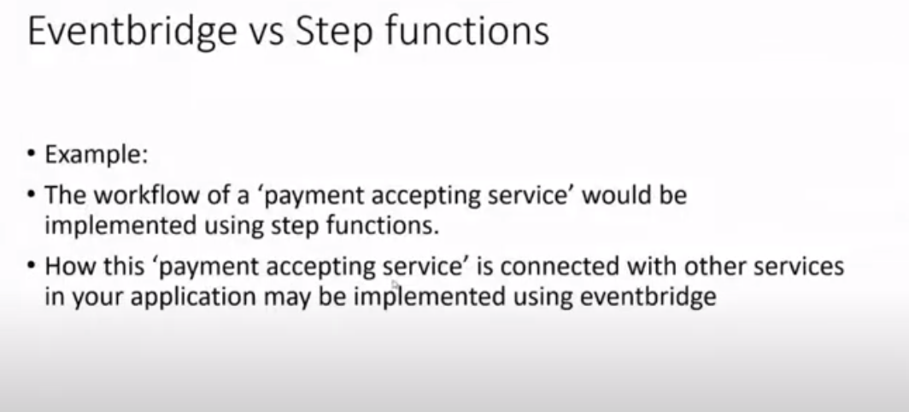CODE EXAMPLE:

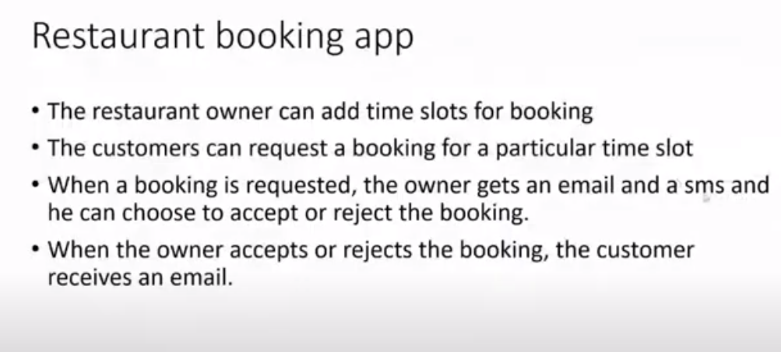

CODE ARCHITECTURE:

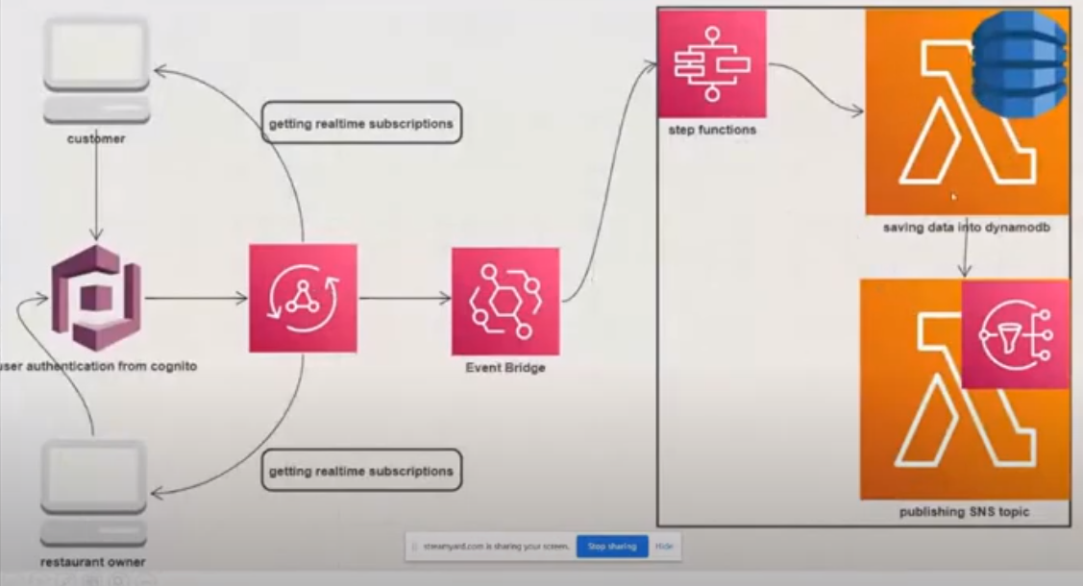

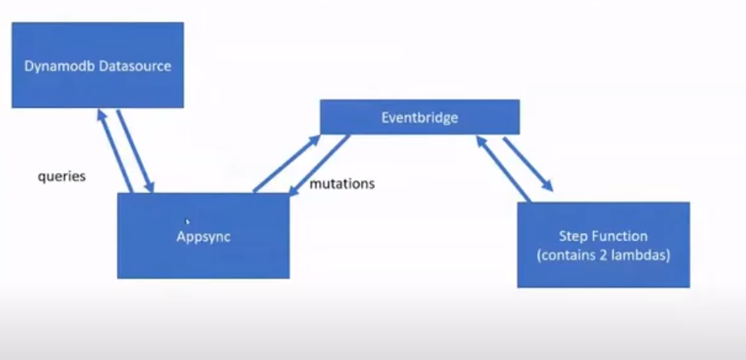queries directly from db, mutation to eventbridge

STEP FUNCTION DETAILS:

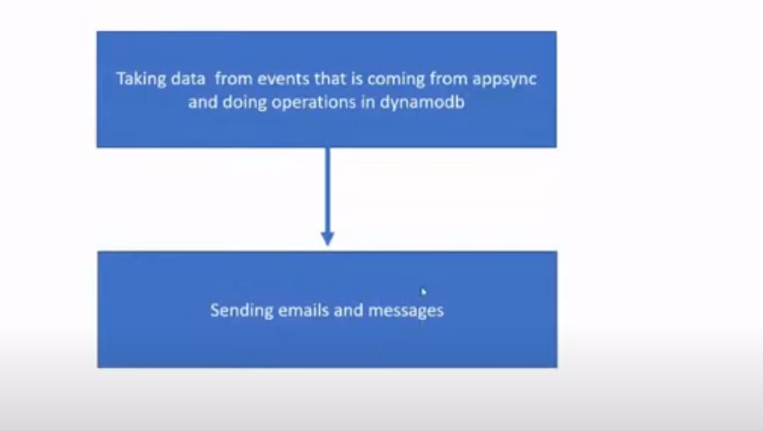

No data source/base:

Two benefits to use it.

1. When we send request(mutation) to eventbridge, eventbridge send response immediately but not insuring whether data added in dynamodb or not, now to update our frontend at real time, we need to run no data source with the latest upadated data with the help of subscriptions for frontend if successful otherwise fail

It is not imp for the backend, just add extra benefit of realtime update using subscription to frontend

1. For example, if we have 3 mutations, we need 3 subscriptions. To reduce subscriptions, we use no data base mutation. When our mutation return any thing, we pass it to no database mutation as input. Now instead of running 3 subscriptions to for 3 mutaions, we simply run one subscription to no database mutation that consist of all 3 mutations output as its input

ONE:

Customers part is our mutations and admins part is subscription which update our frontend admin page.

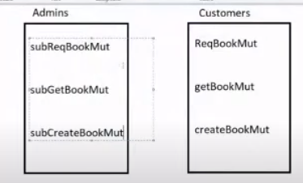

TWO:

Added nodatabase source for every mutation and instead of running 3 subscriptions for 3 mutaions, we only ran one subscription for nodatabase mutation

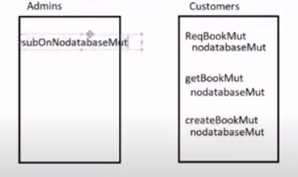

EMAIL :

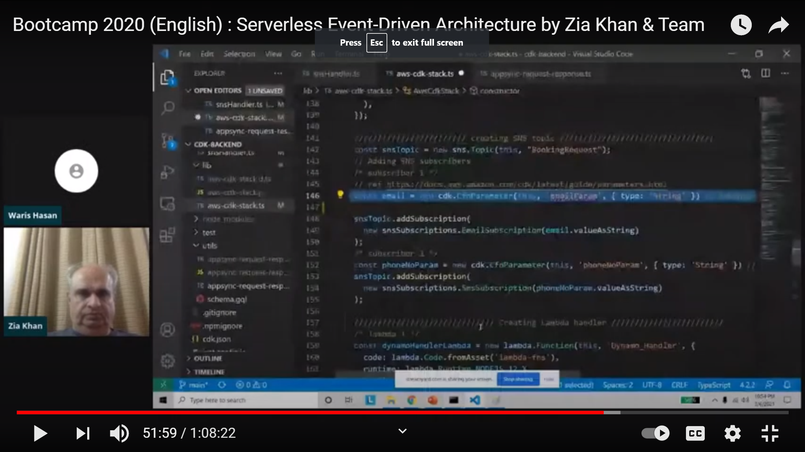

SEND PARAMETERS THROUGH TERMINAL:

